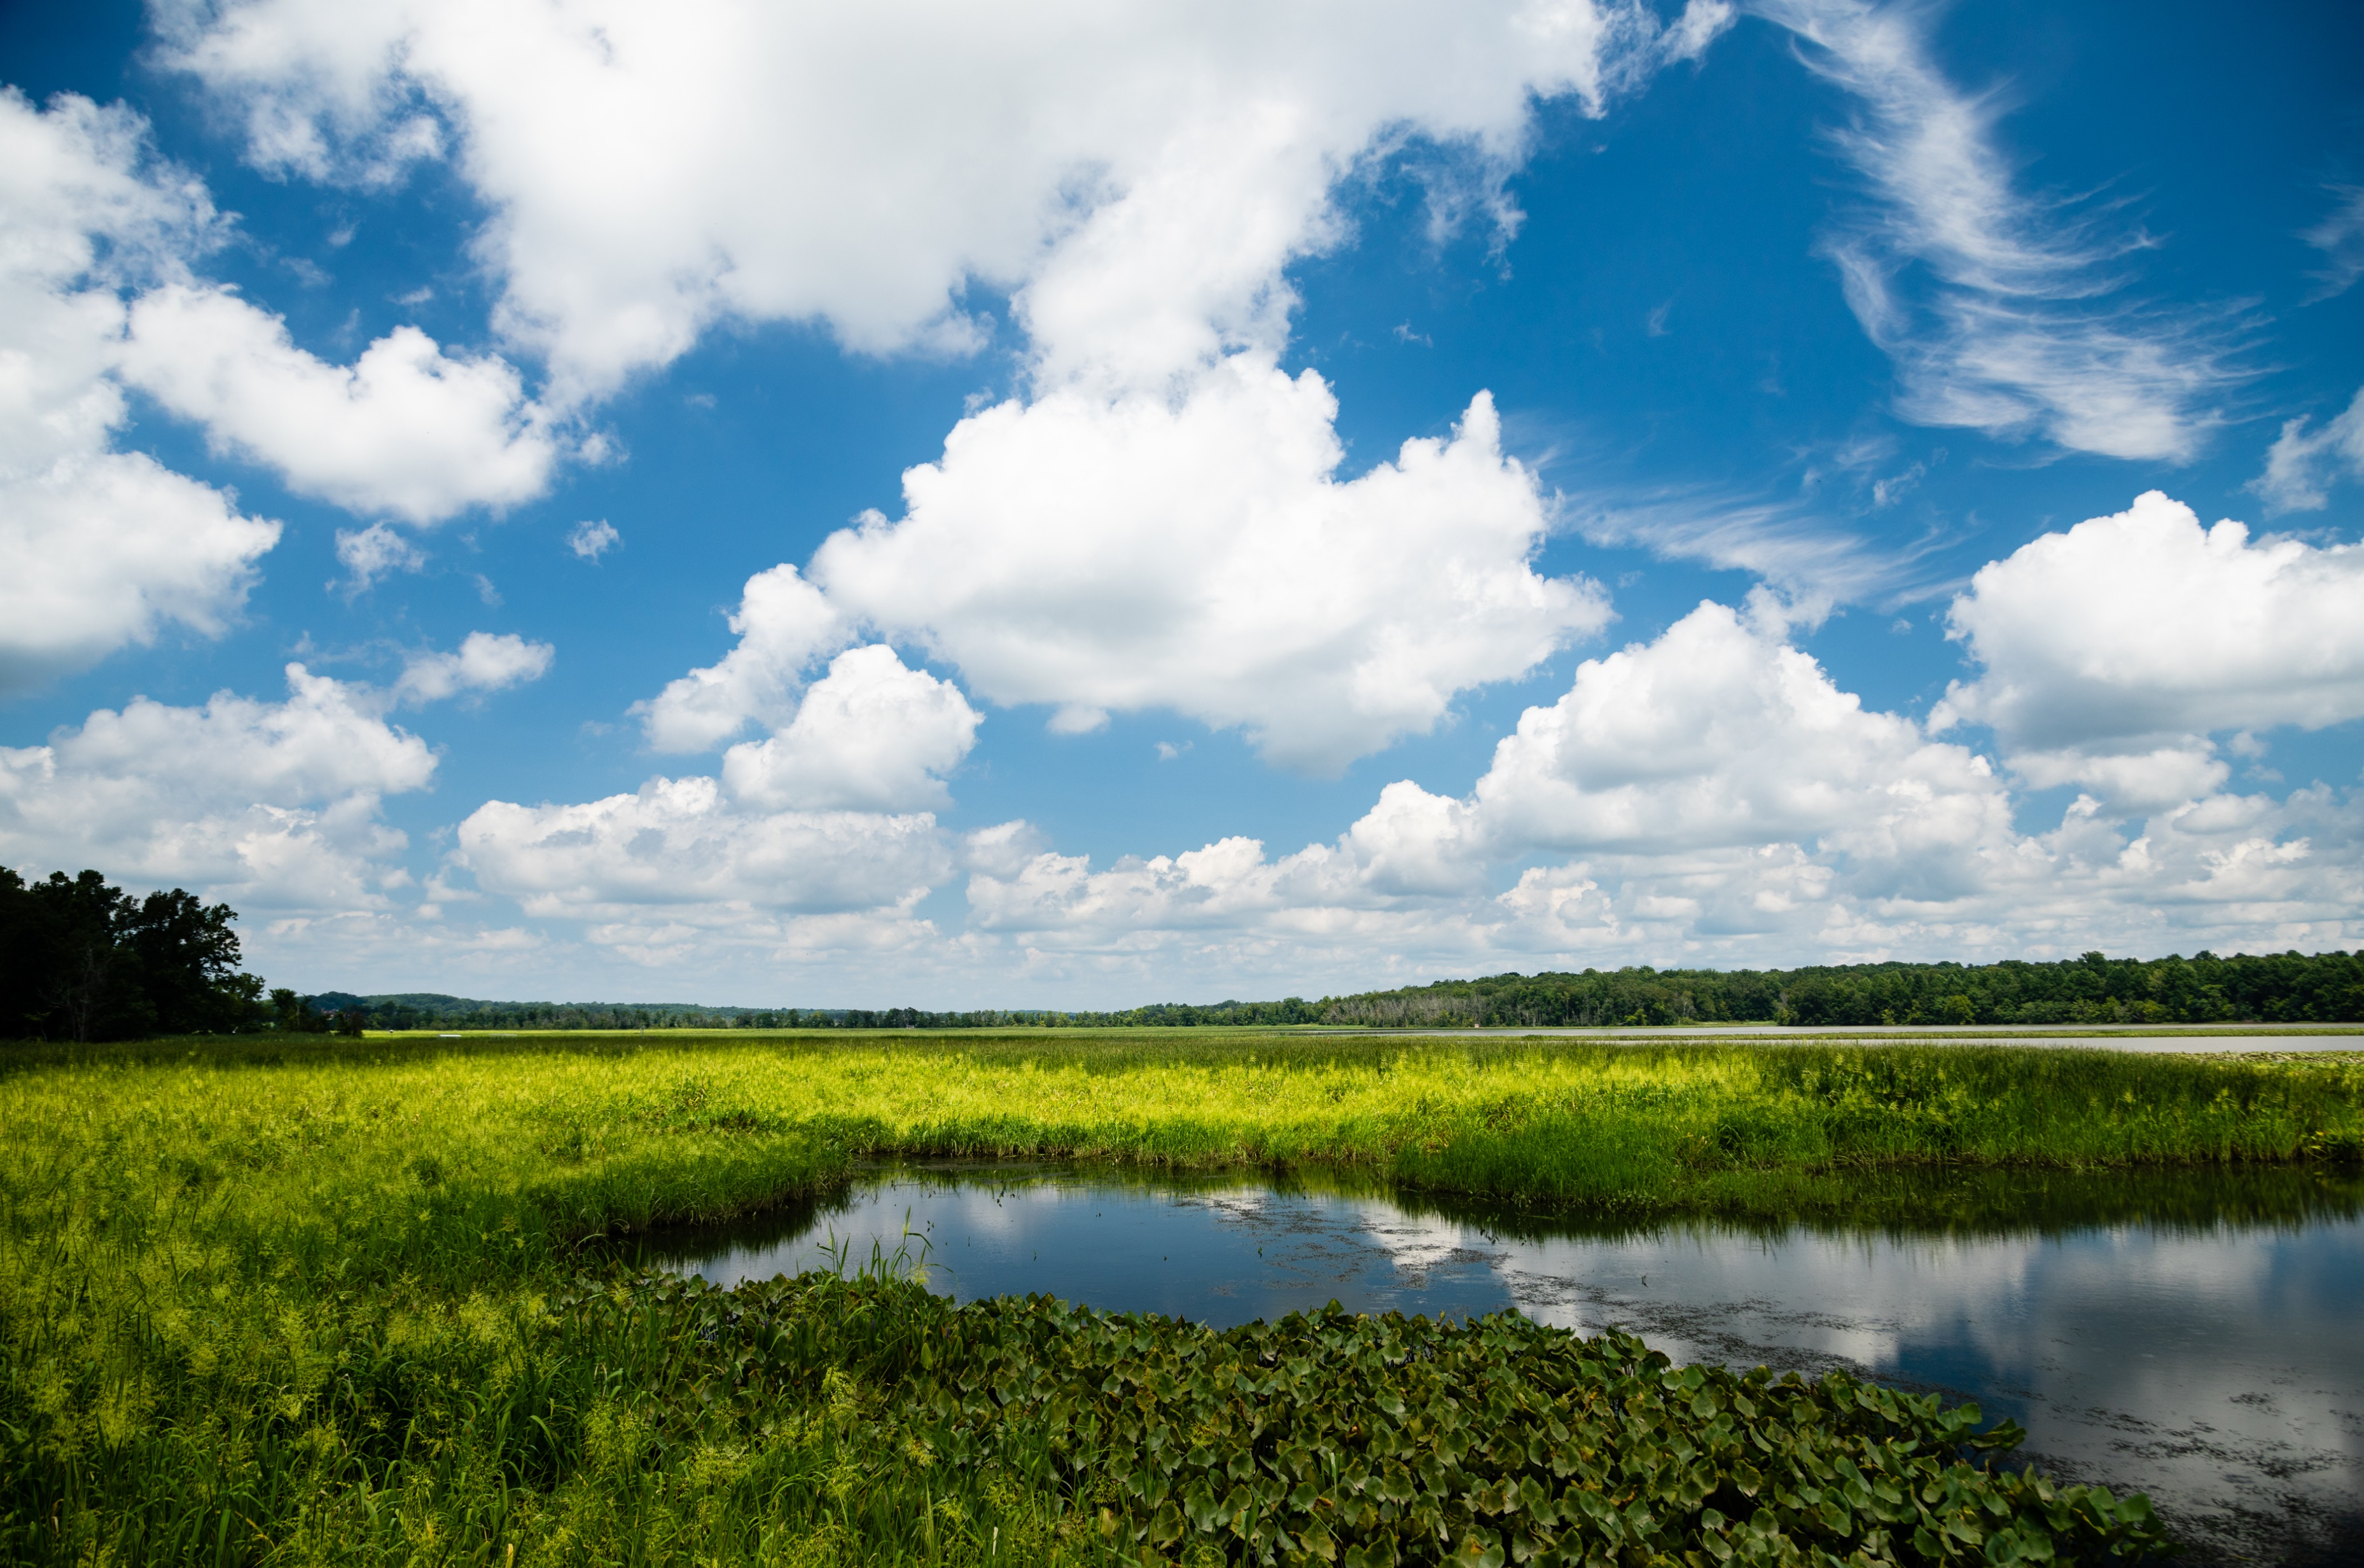

*Updated January 2025*

**TOOLBOX**

*for preparing proposals to the*

**CHESAPEAKE SMALL WATERSHED**

**OR**

**CHESAPEAKE WATERSHED INVESTMENTS FOR LANDSCAPE DEFENSE (WILD)**

**GRANTS**

Cover Photo: Will Parson/ Chesapeake Bay Program

Cover Photo: Will Parson

Cover Photo: Will Parson

INTRO TO NFWF’S CHESAPEAKE BAY STEWARDSHIP FUND

**CHESAPEAKE BAY STEWARDSHIP FUND**

The Chesapeake Bay Stewardship Fund is dedicated to protecting and restoring the bay by helping local communities clean up and restore their polluted rivers and streams. The Fund also advances cost-effective and creative solutions with financial and technical assistance to local communities, farmers and private landowners.

The National Fish and Wildlife Foundation (NFWF) manages the Stewardship Fund in partnership with government agencies and private corporations and in close coordination with the federal-state [Chesapeake Bay Program](https://www.chesapeakebay.net/) partnership. Major funding is provided by the U.S. Environmental Protection Agency through the Chesapeake Bay Program Office, and the U.S. Fish and Wildlife Service. Additional funding is provided by Altria Group, the U.S. Department of Agriculture’s Natural Resources Conservation Service and the U.S. Forest Service.

Since 1999, the Stewardship Fund has worked with the public and private sectors to deliver on-the-ground conservation successes benefiting the communities, farms, habitats and wildlife of the Chesapeake Bay region. NFWF administers the fund’s four competitive grant programs, the Innovative Nutrient and Sediment Reduction Grant Program, the Small Watershed Grants Program, the Chesapeake WILD Grant Program, and Pennsylvania’s Most Effective Basins Grants. NFWF also makes targeted investments that support networking and information-sharing among restoration partners on emerging technologies, successful restoration approaches, and new partnership opportunities.

TOOLS FOR ESTABLISHING OUTCOMES

**WATER QUALITY ANALYSIS, ASSESSMENTS, AND BMPS**

**FieldDoc:** [https://www.fielddoc.org/](https://www.fielddoc.org/login)

To assist applicants in generating credible metric estimates, NFWF has partnered with [The Commons](https://www.ourcommoncode.org/) to develop FieldDoc, a user-friendly tool that allows consistent planning, tracking, and reporting of water quality improvement activities and modeling of associated nutrient and sediment load reductions from proposed grant projects.

**Chesapeake Bay Watershed Data Dashboard:** <https://gis.chesapeakebay.net/wip/dashboard/>

The Chesapeake Bay Watershed Data Dashboard is an online tool developed by the [Chesapeake Bay Program](https://www.chesapeakebay.net/) partnership that provides accessibility and visualization of data and technical information that can help guide water quality and watershed planning efforts.

**Chesapeake Bay Most Effective Basins**: <https://storymaps.arcgis.com/stories/6770277260a2416085f37f7fe026f1bf>

Model My Watershed is a watershed-modeling web app that enables citizens, conservation practitioners, municipal decision-makers, educators, and students to: analyze real land use and soil data in their neighborhoods and watersheds; model stormwater runoff and water-quality impacts using professional-grade models; and compare how different conservation or development scenarios could modify runoff and water quality.

**Chesapeake Assessment Scenario Tool**: <https://cast.chesapeakebay.net/>

The Chesapeake Assessment Scenario Tool (CAST) is a web-based nitrogen, phosphorus and sediment load estimator tool developed by the [Chesapeake Bay Program](https://www.chesapeakebay.net/) partnership that streamlines environmental planning. Users specify a geographical area, and then select Best Management Practices (BMPs) to apply on that area. CAST builds the scenario and provides estimates of nitrogen, phosphorus, and sediment load reductions. The cost of a scenario is also provided so that users may select the most cost-effective practices to reduce pollutant loads.

**CBP Expert Panels and Products**: <https://www.chesapeakebay.net/who/group/bmp_expert_panels>

The [Chesapeake Bay Program](https://www.chesapeakebay.net/) utilizes expert panels to establish BMP efficiencies and loading estimates for incorporating restoration and conservation actions into Chesapeake water quality goals. This one is particularly comprehensive:

* Chesapeake Bay Program Quick Reference Guide for Best Management Practices (BMPs): Nonpoint Source BMPs to Reduce Nitrogen, Phosphorus and Sediment Loads to the Chesapeake Bay and its Local Waters - <https://www.chesapeakebay.net/documents/BMP-Guide_Full.pdf>

**Coastal Resilience and Evaluation Siting Tool (CREST):** <https://resilientcoasts.org/#Home>

CREST uses regional coastal resilience assessments seek to identify areas where natural resource restoration efforts will have the greatest impact for human community resilience, as well as for fish and wildlife, and identifies these types of natural areas as Resilience Hubs. For more information about NFWF’s regional coastal assessment visit <https://www.nfwf.org/programs/national-coastal-resilience-fund/regional-coastal-resilience-assessments>.

**SPECIES AND HABITAT**

**Nature’s Network**: <http://naturesnetwork.org/>

Nature’s Network is a conservation design for the Northeast region, developed by a team of federal, state, academic, and NGO partners based on the best available science at this scale. It identifies a network of connected, intact, and resilient areas -- both lands and waters -- that encompass important habitats for key species. These areas are considered the best places to start for strategic conservation planning to support a sustainable future for both human and natural communities across the 13-state region. Our partners can apply this tool in the Chesapeake Bay watershed to see how local conservation efforts fit into the bigger picture. That regional perspective can amplify local, state and regional conservation priorities by illustrating their significance on a landscape scale. In turn, by complementing regional priorities, our conservation work can make an impact beyond the watershed boundary by supporting the long-term viability of fish and wildlife species across their ranges.

* Prioritization tool: <https://www.naturesnetwork.org/prioritization-tool/>
* Data download: <http://naturesnetwork.org/data-tools/download-tables/>
* Data Basin for live mapping and/or overlay of project boundaries, and map output into PowerPoint, PDF or PNG formats: <https://nalcc.databasin.org/maps/522735111d19494a83b0a3badc710319/>

**Chesapeake Bay Business Plan**: <https://www.nfwf.org/sites/default/files/2019-12/chesapeake-business-plan.pdf>

In 2018, the Board of Directors of the National Fish and Wildlife Foundation approved an update to NFWF’s Chesapeake Bay Business Plan with the input of a broad range of Chesapeake Bay watershed stakeholders, experts, and practitioners. The plan outlines the species, goals, strategies, and activities that will provide the biggest return on investment in the Chesapeake Bay watershed.

**Chesapeake Bay Watershed Priority Brook Trout Stronghold Conservation Analysis Mapping Application**: <https://arcg.is/18Oirf>

This project was produced by [Trout Unlimited](https://www.tu.org/) with funding from the National Fish and Wildlife Foundation. The basic approach of the Conservation Portfolio is to: (1) delineate inter-connected trout habitat patches using brook trout distribution information and fish passage barriers locations (e.g., culverts and dams); (2) attribute patches with population information (e.g., trout density, trout community composition, etc.); and (3) interpret patch attributes to characterize brook trout populations (e.g. identify potential strongholds), evaluate the status of brook trout populations in focal watersheds, and describe specific conservation needs (e.g. riparian restoration, etc.), and important data gaps (e.g., barrier assessment, fish sampling). This information can be used to evaluate potential conservation actions for individual populations or for describing patterns of brook trout status across Chesapeake Bay focal watersheds.

**American Black Duck Non-breeding Watershed Prioritization**: <https://fws.maps.arcgis.com/apps/MapSeries/index.html?appid=6845a4e06da04341ab460607116308b7>

Developed by the [Atlantic Coast Joint Venture](https://acjv.org/) and partners with the Black Duck Joint Venture, [Ducks Unlimited](https://www.ducks.org/), and the [University of Massachusetts Amherst](https://www.umass.edu/), these data show priority watersheds important for meeting American Black Duck population objectives in the Northeast, including:

* Restoration watersheds that do not contain enough food (i.e. energy) to support Black Duck population objectives. Work in these watersheds should focus on restoring additional habitat to support more ducks. Habitat protection of existing and restored wetlands is also important.
* Protection watersheds containing enough food (i.e. energy) to support black duck population objectives, however, much of this food is not found on protected land. Work in these watersheds should focus on protecting additional habitat to ensure Black Duck numbers can be maintained
* Maintenance watersheds currently containing enough food (i.e. energy) to support black duck population objectives and this food is contained on protected lands. Work in these watersheds should focus on maintaining habitat quality to support the current population. This could include restoring or protecting additional habitat should current habitat be lost or degraded (e.g. due to sea level rise).

**NatureServe Explorer**: <http://explorer.natureserve.org/>

NatureServe Explorer is an authoritative source for information on more than 70,000 plants, animals, and ecosystems of the United States and Canada. Explorer includes particularly in-depth coverage for rare and endangered species. Perform searches by Species and/or Ecological Communities & Systems by Name, Taxonomy, Location, or Conservation Status. Use the database to easily find scientific and common names, conservation status, distribution maps, images, life histories, conservation needs, and more.

**NatureServe National Species Dataset**: <https://www.natureserve.org/products/national-species-dataset>

NatureServe’s foundational at-risk species dataset includes more than 900,000 location records (element occurrences) from our Network of biological inventories operating in all 50 states and in most of Canada. Over four decades, this network has collected and managed detailed local information on plants and animals of conservation concern. Representing the best available information on the known location, viability, and other information on at-risk species populations, this dataset is essential to regional and local analyses, decision-making, and planning.

TOOLS FOR A ROBUST PROPOSAL

**CBSF PROPOSAL BEST PRACTICES**

**Metrics Guidance**: <https://www.nfwf.org/sites/default/files/2023-02/2023-swg-wild-metrics-guidance.pdf>

To increase consistency in the usage and calculations of metrics, the NFWF CBSF team has created a “2023 Metrics Guidance” document to provide additional details and instructions about each metric. Ensure that, upon choosing a metric to include in your proposal, the calculation of the target value accounts for the details listed for the metric in the guide.

**PERMITTING AND COMPLIANCE**

**Quality Assurance Project Plan Resources**: <https://www.nfwf.org/programs/chesapeake-bay-stewardship-fund/tools-current-grantees/quality-assurance>

The National Fish and Wildlife Foundation’s Chesapeake Bay Stewardship Fund has an EPA approved Quality Management Plan (QMP) for operations, data collection, and grant making. As part of this QMP, certain projects funded through the Chesapeake Bay Stewardship Fund require that grant agreements contain Quality Assurance Statements (QAS) or language requiring project partners complete a Quality Assurance Project Plan (QAPP) before grant activities, particularly data collection, are undertaken.

Examples of the types of data collection or use which requires a QAPP includes (but is not limited to):

* New data collection
* GIS or secondary data analysis
* Water or other environmental media monitoring including volunteer/community-based efforts
* Data collection and analysis proposed to support decision-making including site assessment prioritization
* Data collection and analysis associated with development or design of plans and projects e.g. fish passage, watershed or water quality/habitat restoration project plans etc.
* Surveying and behavior change work to support decision-making
* Model development or use

**Fish and Wildlife Service NEPA Reference Handbook**: <https://www.fws.gov/node/265335#nepa>

Projects selected will be subject to requirements under the National Environmental Policy Act (NEPA), Endangered Species Act (state and federal), and National Historic Preservation Act. Documentation of compliance with these regulations must be approved prior to DWCF projects initiating activities that disturb or alter habitat or other features of the project site(s). Reimbursement for project activities may be delayed until compliance requirements are complete. Applicants should budget time and resources to obtain the needed approvals. NFWF has made resources available to assist grantees in completing NEPA and other federal compliance upon award. These resources include templates, contacts, and a NFWF-funded consultant available to review documentation and provide process guidance. These resources will be shared at the time of award.

**NFWF GENERAL INFORMATION FOR APPLICANTS**

**Applicant Information**: <https://www.nfwf.org/whatwedo/grants/applicants/Pages/home.aspx>

**Indirect Cost Policy**: <https://www.nfwf.org/apply-grant/application-information/indirect-cost-policy>

**Indirect Cost Calculator**: <https://www.nfwf.org/grants/application-information/indirect-cost-calculator>

**Required Financial Documents**: [https://www.nfwf.org/apply-grant/application-information/required-financial-documents](https:/www.nfwf.org/apply-grant/application-information/required-financial-documents)

*This toolbox is not intended to be exhaustive, guarantee accuracy in estimating outcomes, or endorse the use of any tools over others. These resources should help provide contextual information for proposals. NFWF will update this document regularly as resources become available or are updated. If you have tools and resources you would like to suggest for the toolbox, please feel free to send them to Oleksandr Faryga or Tori Sullens, Managers of Chesapeake Bay Programs* [*Oleksandr.faryga@nfwf.org*](mailto:Oleksandr.faryga@nfwf.org) *or* [*Tori.sullens@nfwf.org.*](mailto:tori.sullens@nfwf.org) *(updated January 2025).*